Master Card API’s
_________________________________________________________________________

Set Environment Variables as :

apiPassword : 6c77e39c8949ab1ed6bc12d3ba576602
fpan : 5123456789012346
username : merchant.SBX_ROGERS
_________________________________________________________________________

But this Tokenized Batch API is not needed for our developement but as I observed these API’s are running in sequence .
When we import the
Postman collection - Rogers_Token_Migratio .postman_collection
_________________________________________________________________________

A. API Name = Submit Batch
- Type : PUT
- URL :
https://pki.mtf.gateway.mastercard.com/batch/version/{{version}}/merchant/{{merchantId}}/batch/{{batchId}}

- URL Preview : https://pki.mtf.gateway.mastercard.com/batch/version/100/merchant/SBX_ROGERS/batch/1764947498571

- Body :
apiOperation,correlationId,customer.email,sourceOfFunds.type,sourceOfFunds.provided.card.number,sourceOfFunds.provided.card.expiry.month,sourceOfFunds.provided.card.expiry.year,result,error.cause,error.explanation,error.field,error.supportCode,error.validationType,token
TOKENIZE,AcctNbr1,test@test.com,CARD,{{fpan}},01,39,,,,,,,
TOKENIZE,AcctNbr2,test2@test.com,CARD,{{fpan}},01,39,,,,,,,
TOKENIZE,AcctNbr3,test3@test.com,CARD,{{fpan}},01,39,,,,,,,
TOKENIZE,AcctNbr4,test4@test.com,CARD,{{fpan}},01,39,,,,,,,
TOKENIZE,AcctNbr5,test5@test.com,CARD,{{fpan}},01,39,,,,,,,

- Auth :
Type : Basic
Password : _.apiPassword

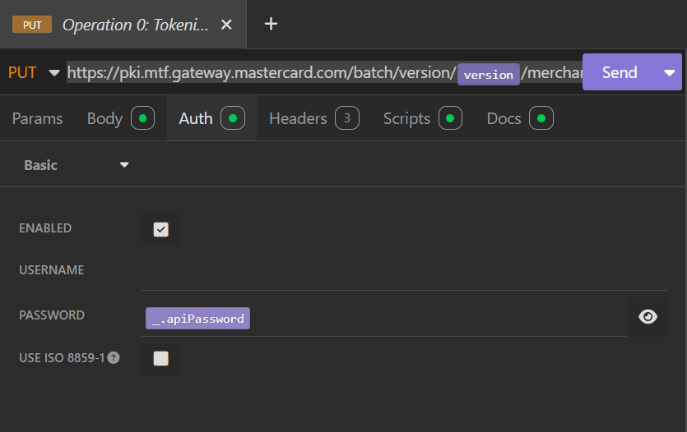
- Header :
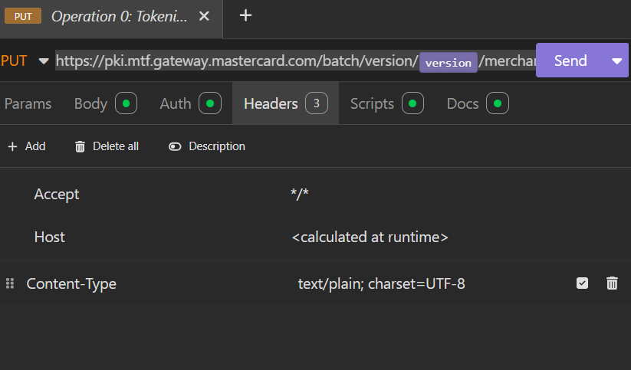
- Check the Script :
First update the script of Tokenize Batch as follows :
// Generate batch id and set it to collection environment
var date = new Date();
var batchId = date.getTime().toString();
insomnia.environment.set("batchId", batchId);
// Evaluate environment variables in the body before calculating SHA1
const requestBody = insomnia.environment.replaceIn(insomnia.request.body.raw);
// Calculate SHA1 and set it to the collection environment
const CryptoJS = require('crypto-js');
const sha1 = CryptoJS.SHA1(requestBody).toString();
insomnia.environment.set("sha1", sha1);
- Result : 200 OK 602ms 238bytes
- Response :
"merchantId","batchName","totalRecords","uploadCompleted","batchStatus","processed","errors","lastAction","processingCompleted"
"SBX_ROGERS","1764947498571","5","2025-12-05T10:11:39-05:00","UPLOADED","0","0","2025-12-05T10:11:39-05:00",""

_________________________________________________________________________

A. API Name = Validate Batch Request
- Type : POST
- Url : https://{{host}}/batch/version/{{version}}/merchant/{{merchantId}}/batch/{{batchId}}/validate
- URL Preview :
https://test-gateway.mastercard.com/batch/version/100/merchant/SBX_ROGERS/batch/1764947498571/validate
- Body : Plain Text
sha1

- Rest all fields same auth, header and script is blank or empty.

- Result : 200 OK 259ms 38bytes
- Response : Digest has been validated successfully
_________________________________________________________________________

B. API Name : Get Batch Status
- Type : GET
- URL : https://pki.mtf.gateway.mastercard.com/batch/version/{{version}}/merchant/{{merchantId}}/batch/{{batchId}}/status
- URL Preview:
https://pki.mtf.gateway.mastercard.com/batch/version/100/merchant/SBX_ROGERS/batch/1767986568573/status
- Param:
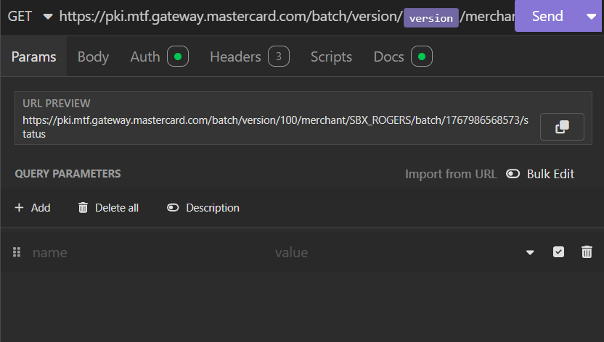
- Body: No Body
- Auth :
  - Type => Basic
  - PASSWORD = _.apiPassword
- Header: same as previous validate API
- Script and Body : Empty/Null
- Result : 200 OK 511ms 263bytes
- Response:
"merchantId","batchName","totalRecords","uploadCompleted","batchStatus","processed","errors","lastAction","processingCompleted"
"SBX_ROGERS","1767986568573","5","2026-01-09T14:22:49-05:00","COMPLETE","5","0","2026-01-09T14:23:06-05:00","2026-01-09T14:23:06-05:00"

_________________________________________________________________________

C. API Name : Get Batch Result
- Type : GET
- URL: https://pki.mtf.gateway.mastercard.com/batch/version/{{version}}/merchant/{{merchantId}}/batch/{{batchId}}/response

- URL Preview:D
https://pki.mtf.gateway.mastercard.com/batch/version/100/merchant/SBX_ROGERS/batch/1767986568573/response

- Param:
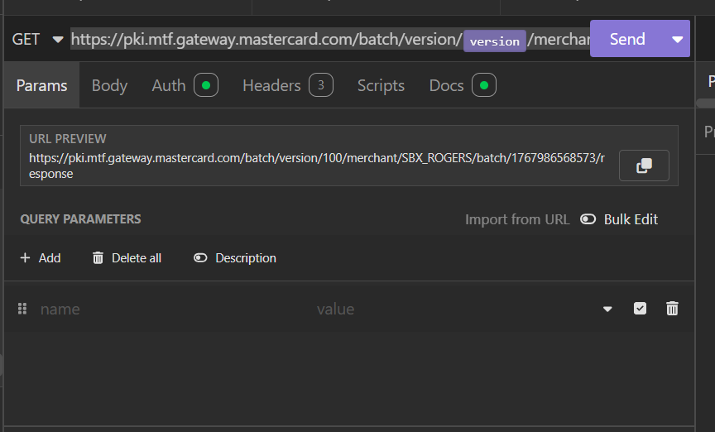
- Body : No Body
- Auth : Same as Get Batch Status
- Header : Same as Get Batch Status
- Script and Docs empty :
- Result : 200 OK 308ms 832bytes
- Response :
"apiOperation","correlationId","customer.email","sourceOfFunds.type","sourceOfFunds.provided.card.number","sourceOfFunds.provided.card.expiry.month","sourceOfFunds.provided.card.expiry.year","result","error.cause","error.explanation","error.field","error.supportCode","error.validationType","token"
"","AcctNbr1","test@test.com","CARD","512345xxxxxx2346","","","SUCCESS","","","","","","9703796509383554"
"","AcctNbr2","test2@test.com","CARD","512345xxxxxx2346","","","SUCCESS","","","","","","9703796509383554"
"","AcctNbr3","test3@test.com","CARD","512345xxxxxx2346","","","SUCCESS","","","","","","9703796509383554"
"","AcctNbr4","test4@test.com","CARD","512345xxxxxx2346","","","SUCCESS","","","","","","9703796509383554"
"","AcctNbr5","test5@test.com","CARD","512345xxxxxx2346","","","SUCCESS","","","","","","9703796509383554"
_________________________________________________________________________

Note : MIT Recurring and Migrated MIT Recurring API’s not needed for our Development

_________________________________________________________________________

_________________________________________________________________________

Sample Credit Card Details To test :

1. Tokens:
- 9682700663813061
- 9656921329414737
- 9012155697701004
- 9507560709550208

2. Amex:
- 343434343434343
- 371449059238428
- 371449914339551
- 371449416683050
- 371449751209263

3. Visa:
- 4444422801988926
- 4444429404278811
- 4444429877475134

4. Mastercard:
- 5500006100036566
- 5500005018768880
- 5500008371050268
________________________________________________________________________

